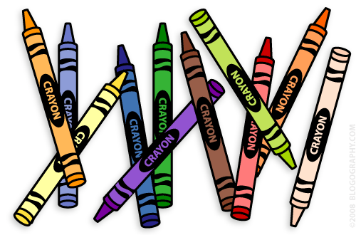**Our 1st Grade Classroom News**

**The Week of Mar. 6th – 24th**

**Email:** [**Lweeks@bluevalleyk12.org**](mailto:Lweeks@bluevalleyk12.org)

**Website:** [**www.bluevalleyk12.org/hes/lweeks**](http://www.bluevalleyk12.org/hes/lweeks)

* We will be working on words that have r-controlled vowels in them. The spelling patterns we will be working on are ‘er’, ‘ir’, and ‘ur’. Example words: h**ur**t, b**ir**d, h**er**, t**ur**key, th**ir**sty, teach**er**

- This newsletter is for March 6th through March 24th because of Spring Break.

-The Challenge of the Week is not due until March 24th.

- On April 17th, we will be going to the Folly Theater for a field trip! We will be watching a production of **The Teacher from the Black Lagoon**. Because there are only limited tickets, only students and teachers are going to this field trip. Permission slips will be going home soon!

**Important Info**

**Upcoming Events**

**Website of the Week**: [This measuring website](http://interactivesites.weebly.com/measurement.html) has lots of fun measuring online games that the kids have loved playing during centers the last couple of weeks. There are easy, average, and hard levels for most of the games!

**App of the Week:**[**Barefoot World Atlas**](https://itunes.apple.com/us/app/barefoot-world-atlas/id489221652?mt=8) is a great app for any student interested in different countries (which is most of the students!). The students click on the different countries and they can learn everything about that country! Lots of great information!

**Tech of the Week**

**March 10th – 20th** NO SCHOOL

**March 28th** Early Release Day

**Apr. 17th** Field Trip to Folly Theater

**Apr. 18th** Early Release

**Challenges of the Week**

**Math Challenge of the Week:**Let your child choose what they want to practice at home from the list below! Have them create their own problems and solve it on their own! Depending on the type of problems they decide on, they need to do anywhere between 3-10 problems.

Double digit addition   
double digit subtraction  
multiplication  
measurement  
rounding  
time to the hour  
 **Reading Challenge of the Week:** We have been identifying books that have words that are supposed to be ‘sound words’. We learned that these words are called onomatopoeia words. Have your child read different books and make a list of onomatopoeia words! Here are some examples: sizzle, boom, crackle, bam, swish, knock  
  
**Writing Challenge of the Week:** Many students are still struggling to write complete stories that have capitals where they need to go and punctuation marks where they need to go. Have your child write a story with a beginning, middle, and end that has at least 5 sentences. Then go back and edit the story with your child. Did they stretch out their sounds for each word? Did they start each sentence with a capital? Did the end each sentence with a period or explanation point?